**Lexar® Professional SILVER PLUS microSDXC™ UHS-I Card**

1TB

512GB

256GB

128GB

[Where to buy](https://americas.lexar.com/product/lexar-professional-silver-plus-microsdxc-uhs-i-card/)

**Key Features:**

**Up to 205MB/s read, 150MB/s write speeds**

* Rated V30, it supports up to 4K 60fps video recording to capture smooth, high-quality video
* Extensive compatibility with a variety of devices,  
  including models from DJI, GoPro, Nintendo, and SteamDeck and an SD adapter for further compatibility
* Built for durability – IPX7 waterproof, wearproof, drop-proof, temperature-proof, x-ray-proof, shockproof, magnetic-proof, and vibration-resistant
* Peace of mind included with Lexar Recovery Software and a lifetime limited warranty

**Key Features:**

**Up to 205MB/s read, 150MB/s write speeds**

* Rated V30, it supports up to 4K 60fps video recording to capture smooth, high-quality video
* Extensive compatibility with a variety of devices,  
  including models from DJI, GoPro, Nintendo, and SteamDeck and an SD adapter for further compatibility
* Built for durability – IPX7 waterproof, wearproof, drop-proof, temperature-proof, x-ray-proof, shockproof, magnetic-proof, and vibration-resistant
* Peace of mind included with Lexar Recovery Software and a lifetime limited warranty

**Key Features:**

**Up to 205MB/s read, 150MB/s write speeds**

* Rated V30, it supports up to 4K 60fps video recording to capture smooth, high-quality video
* Extensive compatibility with a variety of devices,  
  including models from DJI, GoPro, Nintendo, and SteamDeck and an SD adapter for further compatibility
* Built for durability – IPX7 waterproof, wearproof, drop-proof, temperature-proof, x-ray-proof, shockproof, magnetic-proof, and vibration-resistant
* Peace of mind included with Lexar Recovery Software and a lifetime limited warranty

**Key Features:**

**Up to 205MB/s read, 150MB/s write speeds**

* Rated V30, it supports up to 4K 60fps video recording to capture smooth, high-quality video
* Extensive compatibility with a variety of devices,  
  including models from DJI, GoPro, Nintendo, and SteamDeck and an SD adapter for further compatibility
* Built for durability – IPX7 waterproof, wearproof, drop-proof, temperature-proof, x-ray-proof, shockproof, magnetic-proof, and vibration-resistant
* Peace of mind included with Lexar Recovery Software and a lifetime limited warranty

[Features](https://americas.lexar.com/product/lexar-professional-silver-plus-microsdxc-uhs-i-card/#feature-section)[Specifications](https://americas.lexar.com/product/lexar-professional-silver-plus-microsdxc-uhs-i-card/#specifications)[Part Numbers](https://americas.lexar.com/product/lexar-professional-silver-plus-microsdxc-uhs-i-card/#product-numbers)[Related products](https://americas.lexar.com/product/lexar-professional-silver-plus-microsdxc-uhs-i-card/#related-products)

**Features**

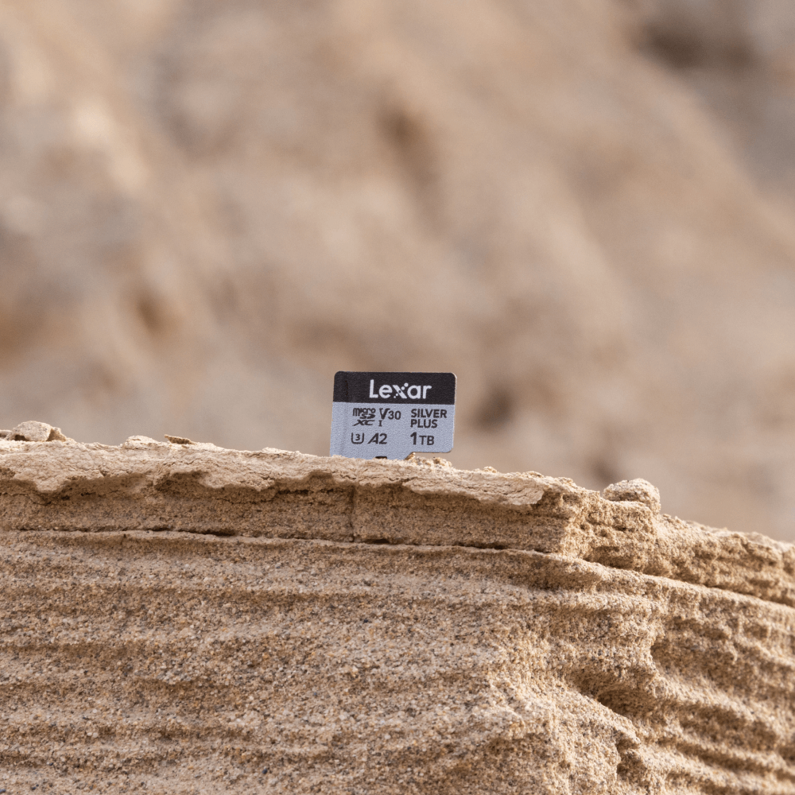

**Outstanding Performance, Exceptional Experience**

The Lexar Professional SILVER PLUS microSDXC™ UHS-I Card boasts exceptional read/write speeds of up to 205MB/s and 150MB/s and supports seamless recording of FULL-HD and 4K videos. Paired with the Lexar RW310x reader, its blazing-fast read speeds are fully achieved, significantly reducing wait times for data transfers. Reliable, durable, and compatible, it is perfect for drones, action cameras, handheld consoles, and more.

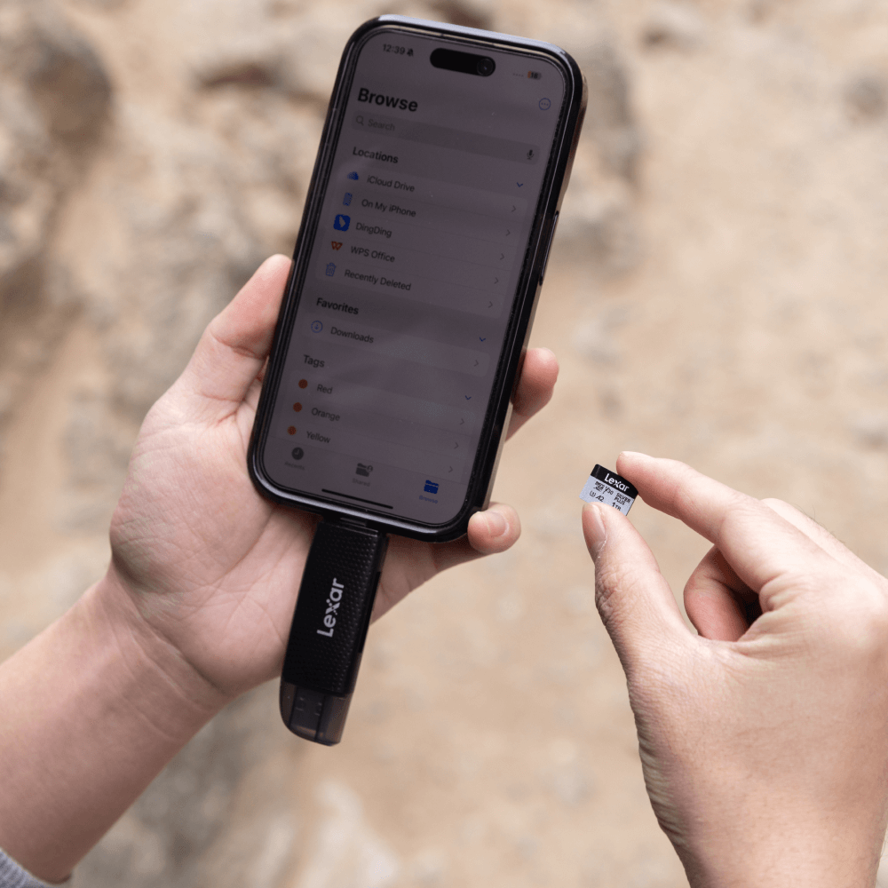

**Performance When it Counts**

With max read speeds of 205MB/s, you can power through transfers and make long wait times a thing of the past. Max write speeds of 150MB/s let you capture burst photos without missing a shot.

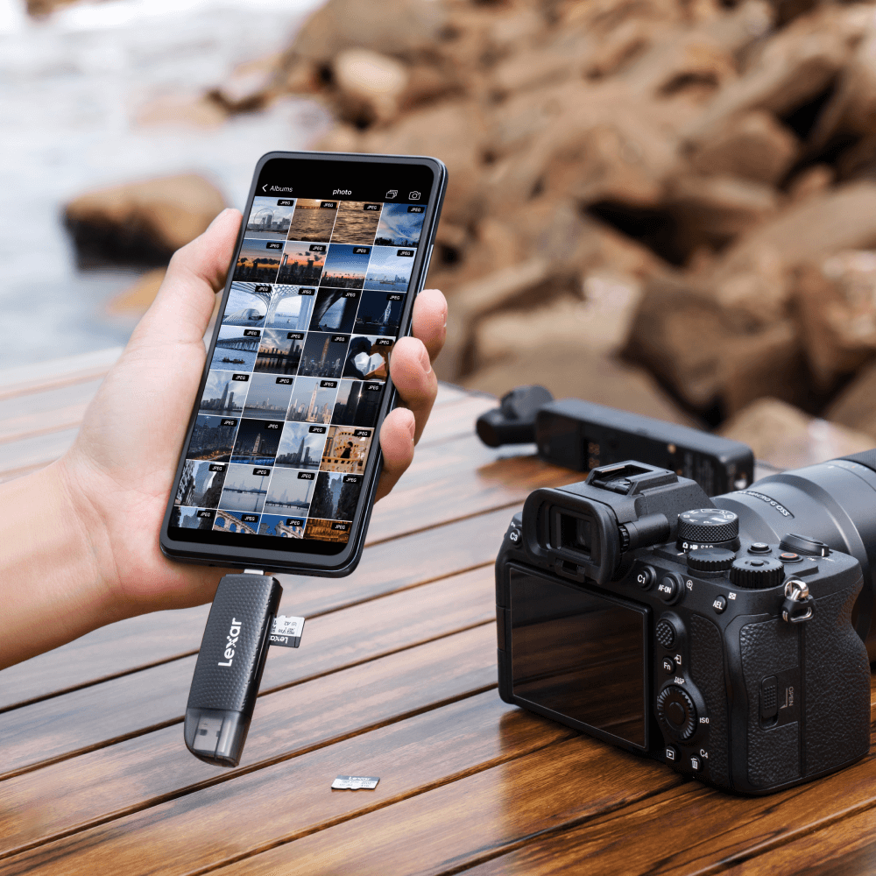

**Video Recording as Detailed as You Are**

Rated V30, the Lexar Professional SILVER PLUS microSDXC™ UHS-I Card is built to capture burst photos without missing a shot and smoothly shoots up to 4K 60fps ultra-HD video.

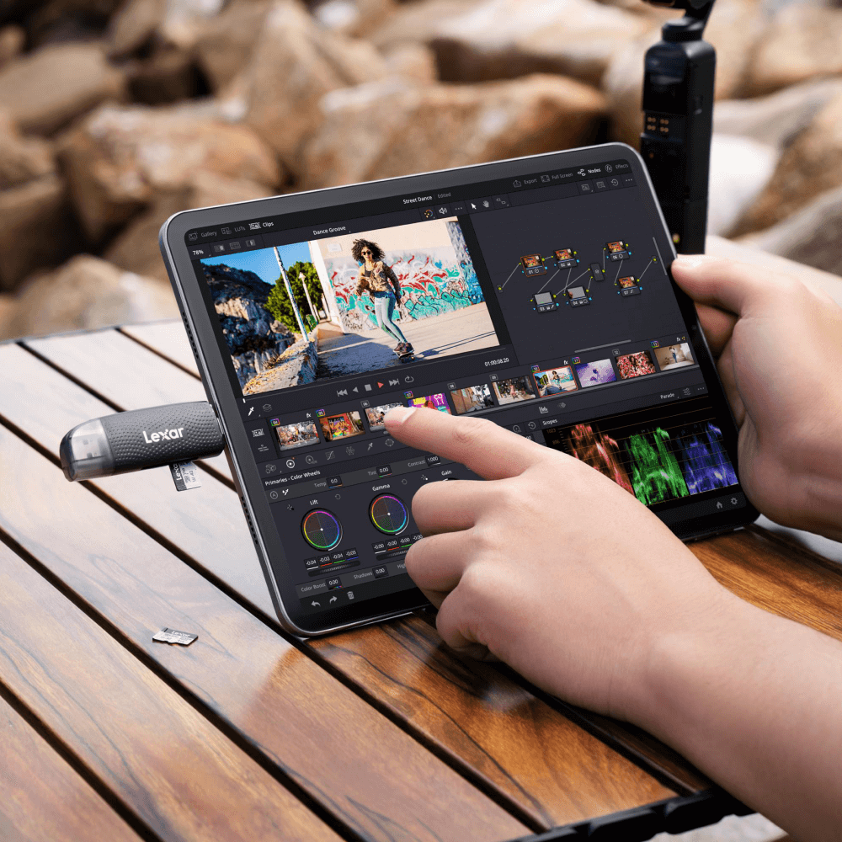

**Extensive Compatibility**

Tested to ensure compatibility with devices from DJI, GoPro, Nintendo, SteamDeck, and more

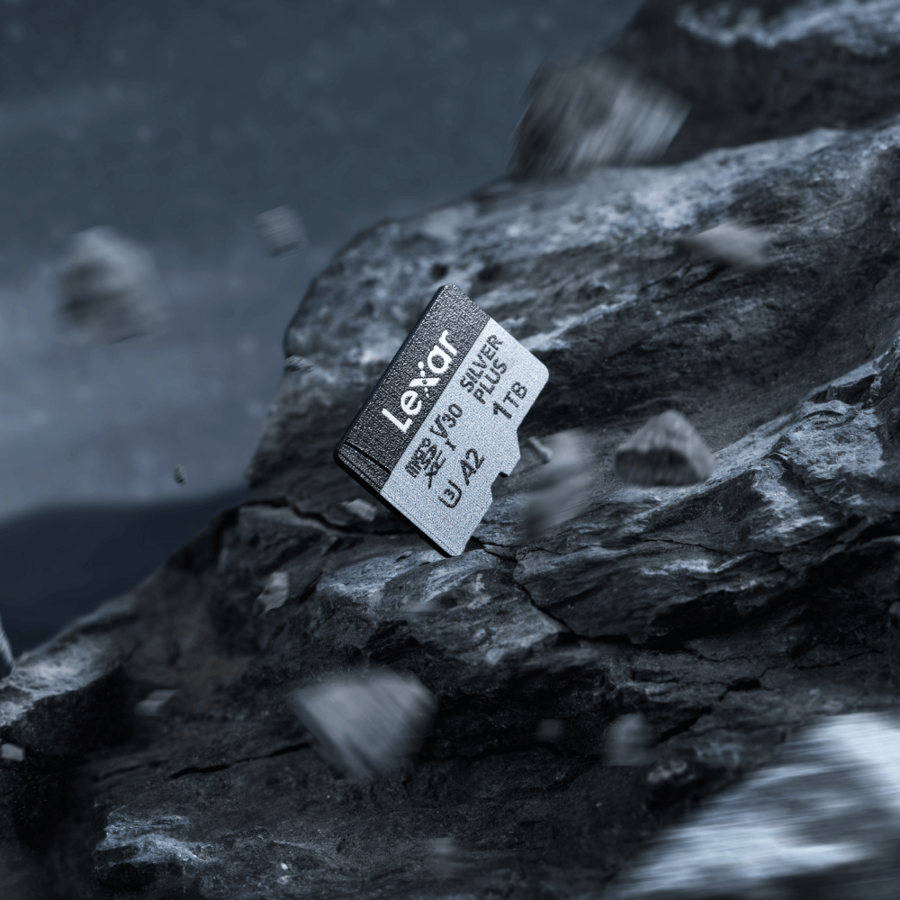

**Tough Enough**

Built for durability, the card is wearproof, temperature-proof, x-ray-proof, vibration-resistant, magnetic-proof, shockproof, and drop-proof so you can be confident taking it wherever your shoot takes you.

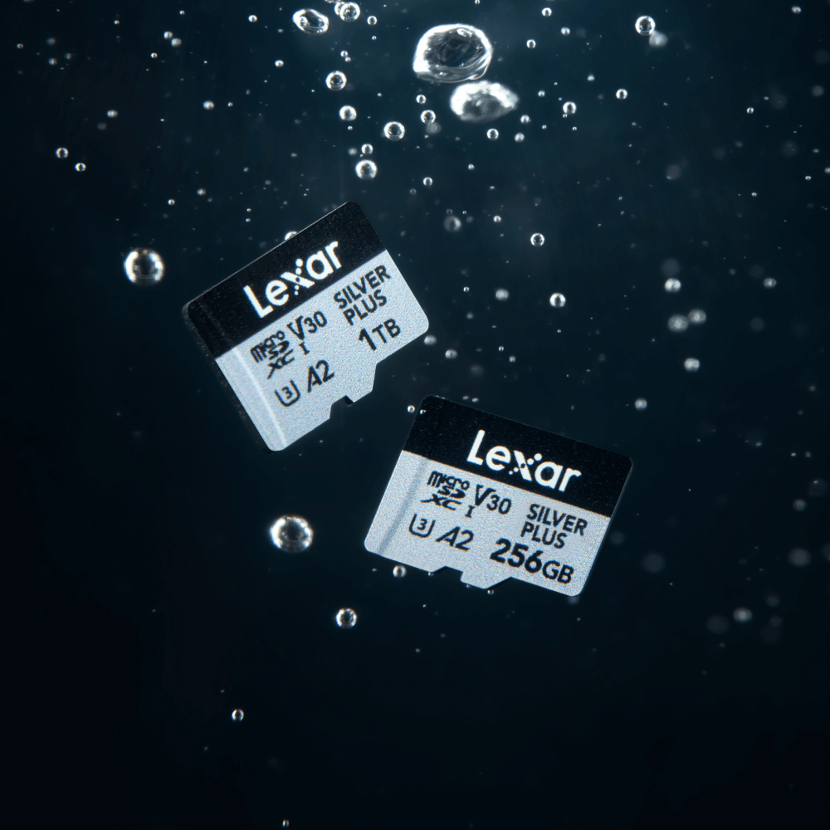

**Peace of Mind Included**

This card comes with Lexar Recovery Tool to help you recover accidentally deleted files and is covered by a lifetime limited warranty.

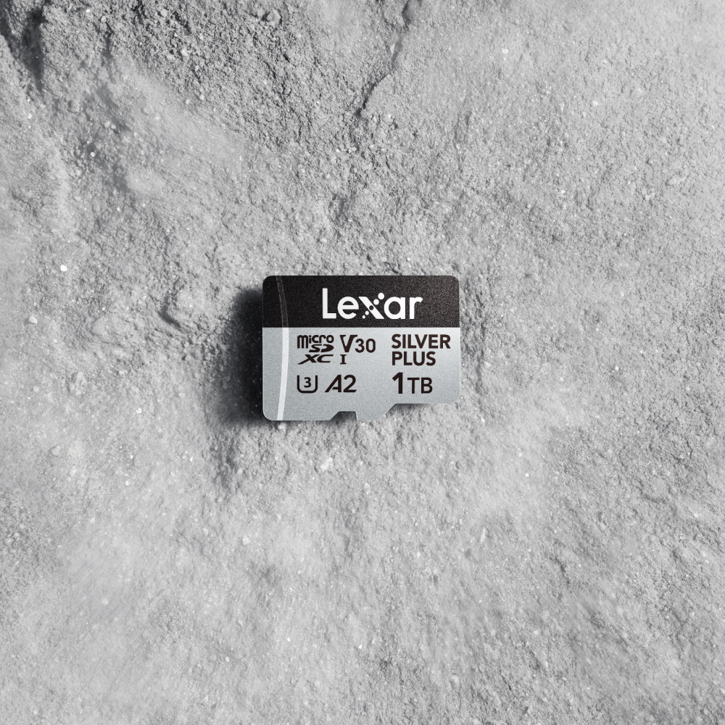

**Rigorously Tested**

All Lexar products undergo extensive testing in the Lexar Quality Labs, facilities with thousands of different cameras and digital devices to ensure performance, quality, compatibility, and reliability.

**Specifications**

* Capacities

1TB | 512GB | 256GB | 128GB

* Performance

Up to 205MB/s read, 150MB/s write speeds1

* Operating Temperature

-25°C to 85°C (-13°F to 185°F)3

* Storage Temperature

-40°C to 85°C (-40°F to 185°F)

* Dimension (L x W x H)

0.43” x 0.59” x 0.04”

* Weight

0.009 oz

* Warranty

Limited Lifetime Warranty2